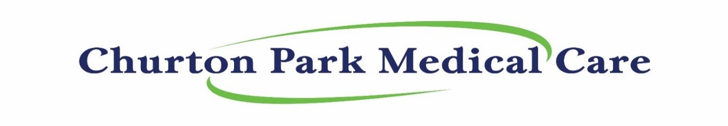
ManageMyHealth (MMH) registration form (16 years and older)
Please complete, sign and return to Churton Park Medical Care: (reception@cpmc.co.nz)

Full Name: _______________________________________________Mobile: __________________________________

Date of Birth: ______________________________ Preferred Name (if applicable) _______________________________

Email Address: _____________________________________________________________________________________
(PLEASE PRINT EMAIL ADDRESS CLEARLY THANK YOU) NB: Each MMH Account must have their own email
ManageMyHealth™ is a website that uploads your patient information from our computers to their encrypted web server. It is a place where you can access your health information online via www.managemyhealth.co.nz, and facilitates secure electronic communication. However, this means your health information will be duplicated onto a server that is OUTSIDE of Churton Park Medical Care’s internal servers. Churton Park Medical Care DOES NOT control the information residing in ManageMyHealth™ servers.
IMPORTANT - THIS IS A NON-URGENT SERVICE. PLEASE DO NOT USE MANAGEMYHEALTH™ TO COMMUNICATE ACUTE SERIOUS PROBLEMS TO YOUR DOCTOR. PLEASE PHONE US ON (04) 4770014
REPEAT PRESCRIPTIONS
We encourage you to use the Request Prescription service. This service is only available for medications marked LONG-TERM. You will receive an email when your doctor has completed the prescription. Please allow 2 working days for this service.
Extra costs will apply for urgent or faxed prescriptions.

TEST RESULTS
You can use ManageMyHealth™ as one of the ways of getting your test results. When we file a result you will be sent an email saying your record has been updated, unless you switch off the automatic notification box in your inbox setup. Your 'Lab Results' section in the 'Health Summary' option will have your results

HEALTH INFORMATION If you see incorrect information in the ‘Health Summary’, please contact the practice so we can correct it.

TECHNICAL SUPPORT
The website is provided by MedtechGlobal, a New Zealand company that provides the software that Churton Park Medical Care uses. They are unable to see your information, as it is encrypted.

I have read and understood the above information.
I am aware that these terms and conditions are subject to change from time to time, as new services become available.
I am aware that this is a non-urgent service. For acute issues, I will call the medical centre on 04 4770014, or 111 in an emergency. I am aware that my health information are duplicated onto MANAGEMYHEALTH™ servers that are separate to Churton Park Medical Care’s internal server.
I am aware that services provided via MANAGEMYHEALTH™ may incur fees and are subject to payment terms.

DATE: _____________________________

SIGNED: __________________________________________________________________

The Email for www.ManageMyHealth.co.nz requires a secure, private email per person, not a work email or one shared with others.

