

**CHRISTMAS OPENING HOURS 2024/25**

**Monday 23rd December - 8:30am - 5pm**

**Tuesday 24th December - 8.30am – 12.30pm**

**Christmas Day 25th December – Closed**

**Boxing Day Tuesday 26th December – Closed**

**Friday 27th December 8.30am – 5pm**

**Saturday 28th December - Closed**

**Sunday 29th December - Closed**

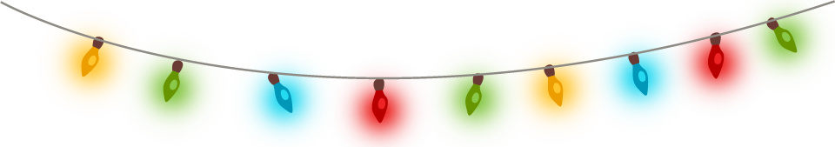

**Monday 30th December - 8.30am – 5pm**

**Tuesday 31st December - 8.30am – 12.30pm**

**New Year’s Day 1st January – Closed**

**New Year’s Holiday 2nd January – Closed**

**Friday 3rd January - 8.30am – 5pm**

**Saturday 4th January - Closed**

**Sunday 5th January - Closed**

**Monday 6th January - 8.30am - 5pm**

**Tuesday 7th January - 8.30am - 5pm**

**Wednesday 8th January - 8.30am - 5pm**

**Thursday 9th January – 8.30am – 5pm**

**Friday 10th January – 8.30am – 5pm**