OFFICE USE ONLY: 1. PHOTO ID SIGHTED & COPIED
2. VISA/RESIDENT STATUS SIGHTED & COPIED

OVERDUE ACCOUNTS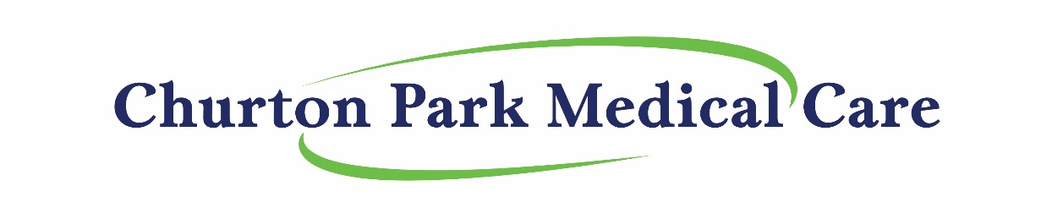
DEBT COLLECTION POLICY
The following is our debt collection policy:
“We pride ourselves on giving the best possible general medical care available, but in order to do that and to keep our charges at a reasonable level, we would like you to be aware of our policy with regard to non payment of your account. This is as follows:
- Payment for your Consultation is expected on the day of consultation

- When payment is not made immediately, accounts must be paid before the end of the calendar month. If payment is not made by that time, an administration fee of $5 will be added at that time.

- Credit extending beyond one month must be arranged with the Practice Manager or the Doctor concerned, and alternative arrangements made for payment.

- All accounts extending past the 90 day due period will be referred to a debt collection agency (unless credit arrangements have been made) and the costs associated with this will be added to the patients account for payment.

- Churton Park Medical Care reserves the right to vary this policy as it sees fit.
If you should have any queries regarding this policy, please do not hesitate to contact me.

We would appreciate your signature at the bottom of this form acknowledging that you have read this policy and understand the implications of non-payment.
Beverley Downes
PRACTICE MANAGER

I acknowledge that I have read the above policy and agree to abide by these terms of payment.

Name:………………………………………………………………………. Signature:…………………………………………..
(Print full name and sign – one per family member over 16 years of age)

