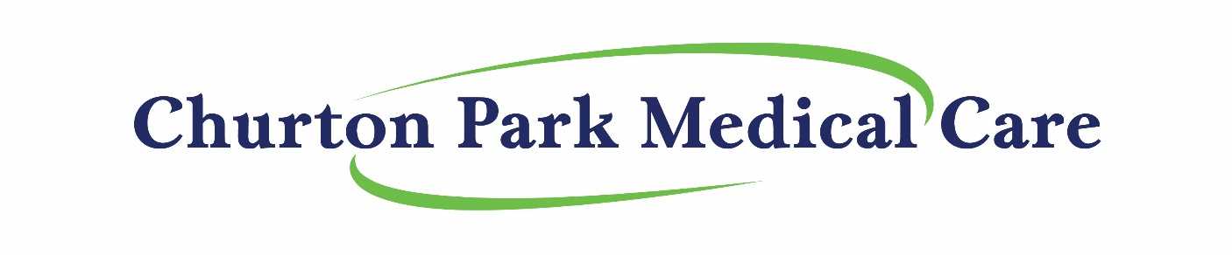

ManageMyHealth (MMH) registration form (16 years and older)

Please complete and return to Churton Park Medical Care:

Full Name: ___________________________________________________________________

Preferred name: ______________________________________________________________

Date of Birth: _________________________________________________________________

My Mobile number is: _________________________________________________________

Email Address: _______________________________________________________________
NB: Only one person is able to be enrolled per email address

Signature: ___________________________________________________________________

Date: ________________________________________________________________________

